Sudoku App Quiz

Amar Maharaj; Kyle Martinez; Bradley Zarek

Dr. Shankar

FAU ESP

# Sudoku App Commentary

## Sudoku Version 0

### Screenshots

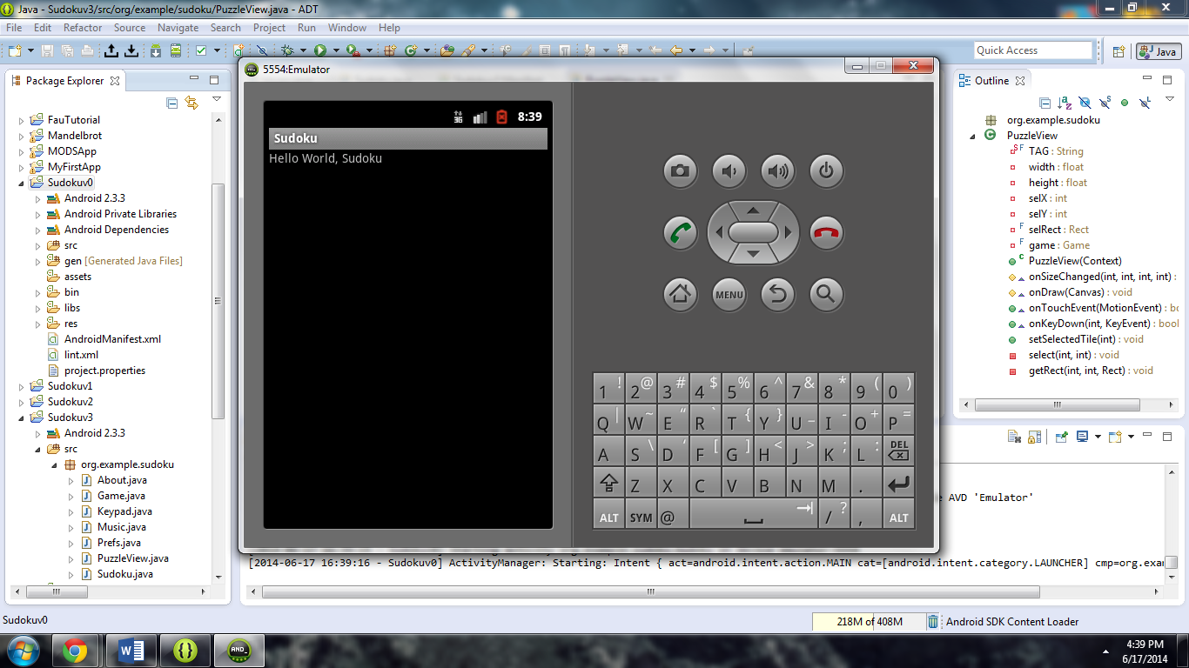

### About

This particular version of the Sudoku app only has a single activity capable of displaying “Hello World, Sudoku” to the screen.

## Sudoku Version 1

### Screenshots

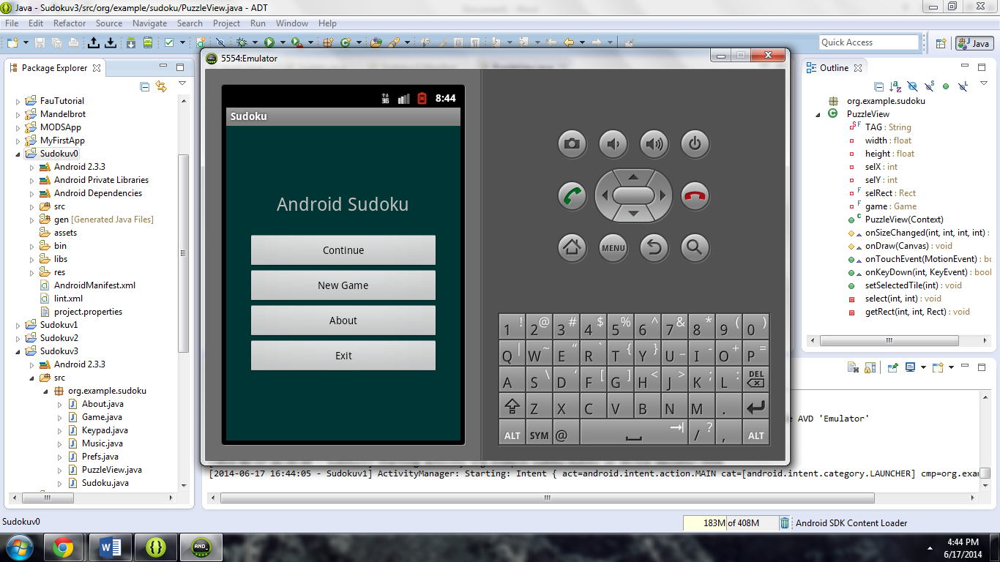

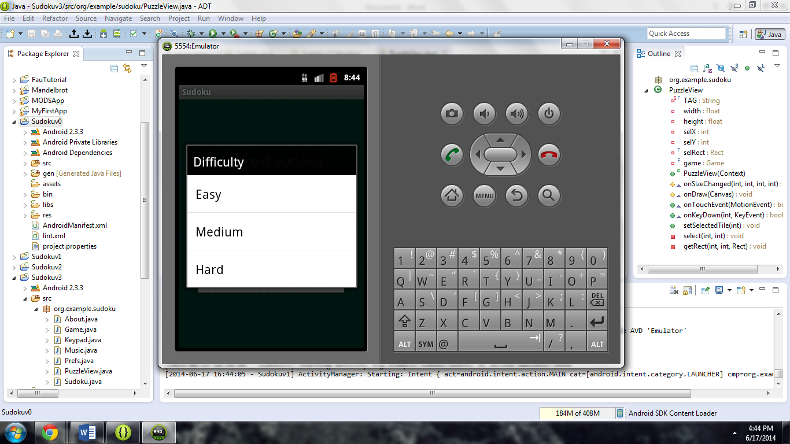

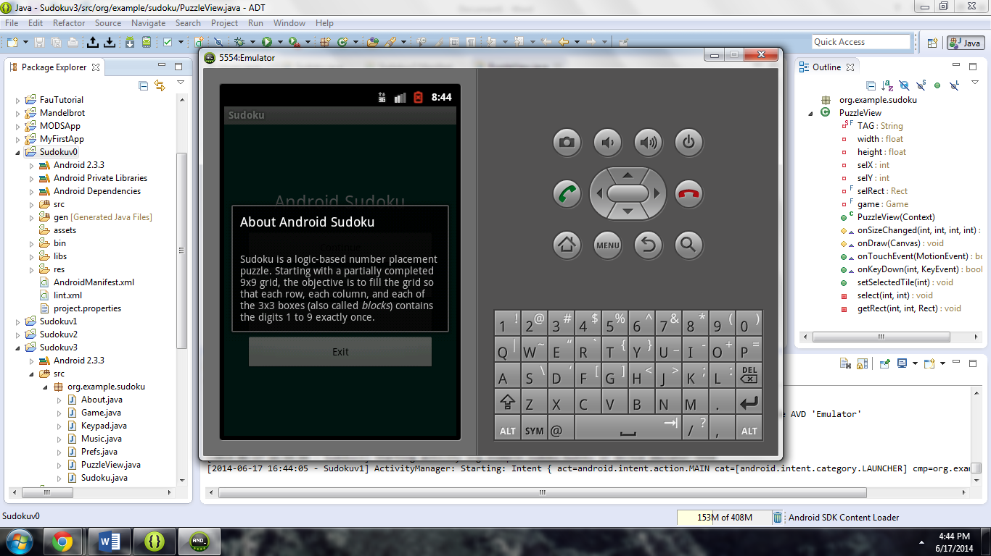

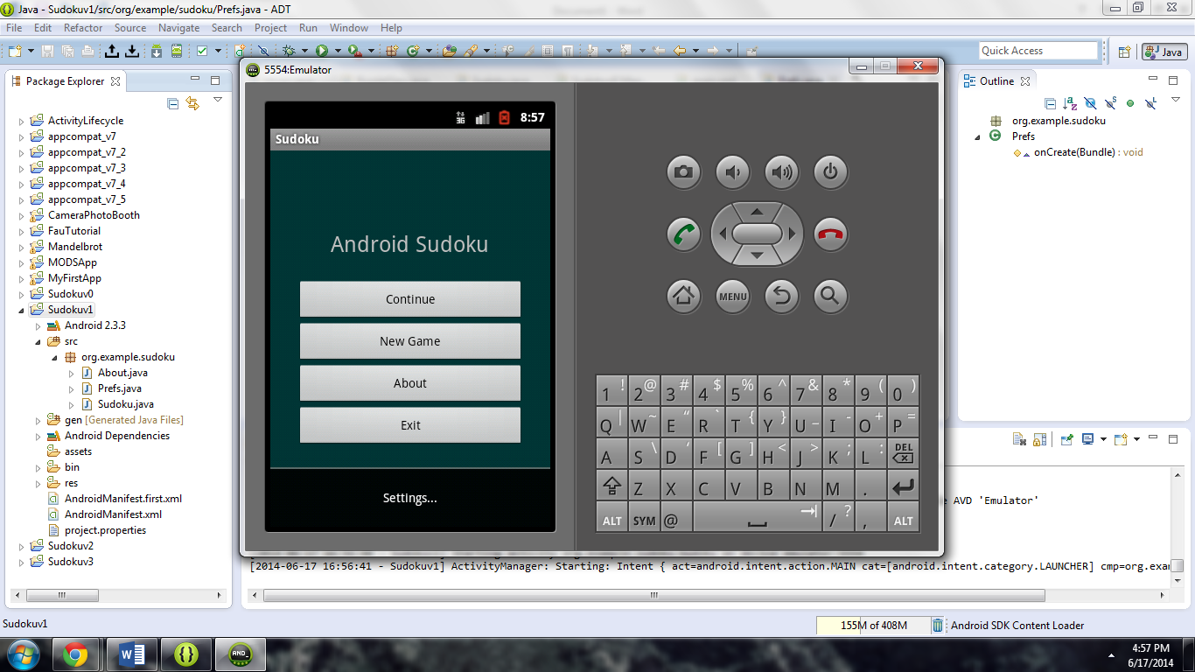

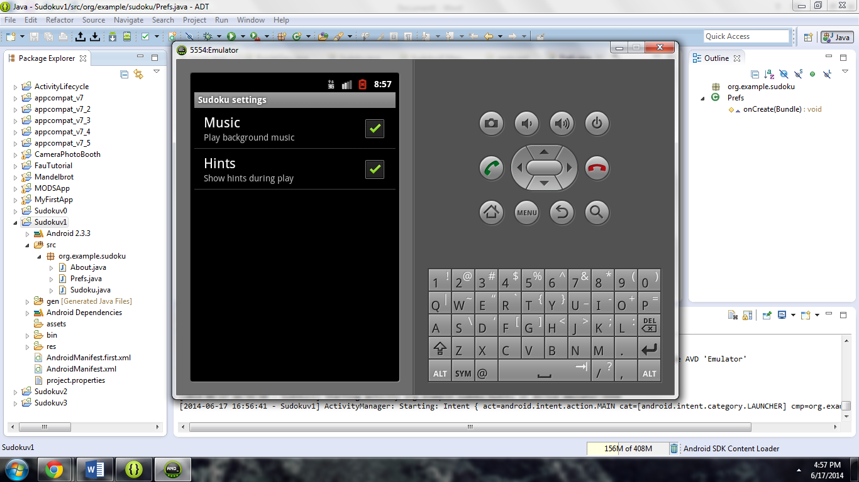

### About

This particular version of the Sudoku app has three activities. One being the main menu, one detailing the specifics of the app (about screen), and a third providing settings to enable or disable hints and music. With this version also comes the ability to select the difficulty of the game from a list. However, the ability to actually play the game has not yet been implemented.

## Sudoku Version 2

### Screenshots

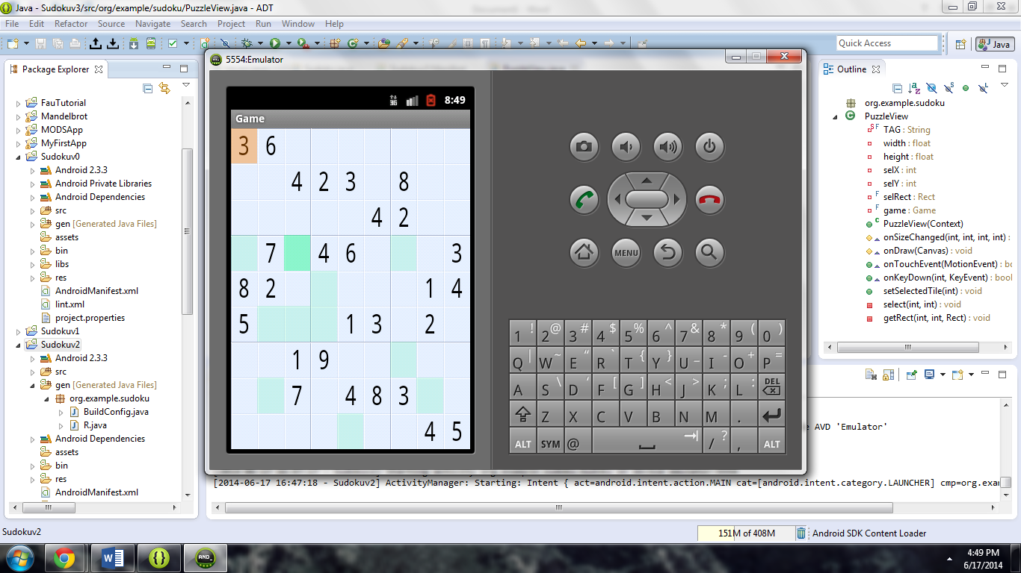

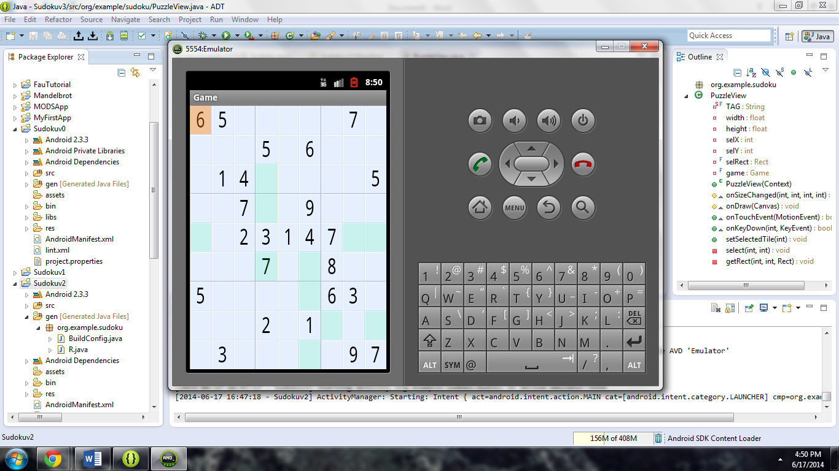

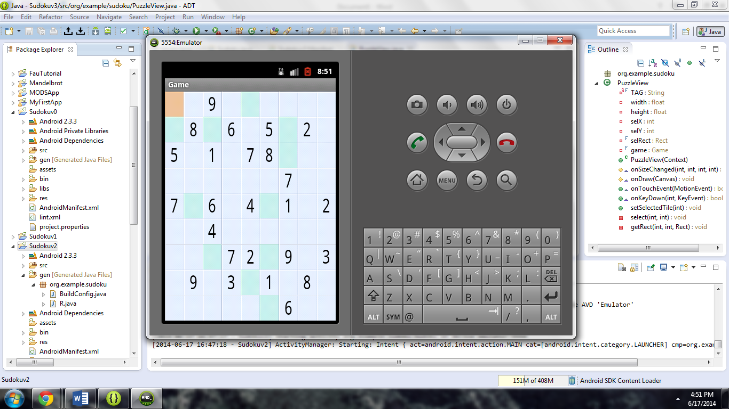

### About

With this particular version of the Sudoku app gameplay now exists. We can now select a difficulty and receive a corresponding game setup to match.

## Sudoku Version 3

### Screenshots

No visual changes were made.

### About

The only changes with this particular version of the Sudoku app is the addition of music.

## Sudoku Version 4

### Screenshots

No visual changes were made.

### About

This particular version of the Sudoku app has the ability to continue a game where it last left off.

# Modified Sudoku App

## Screenshots

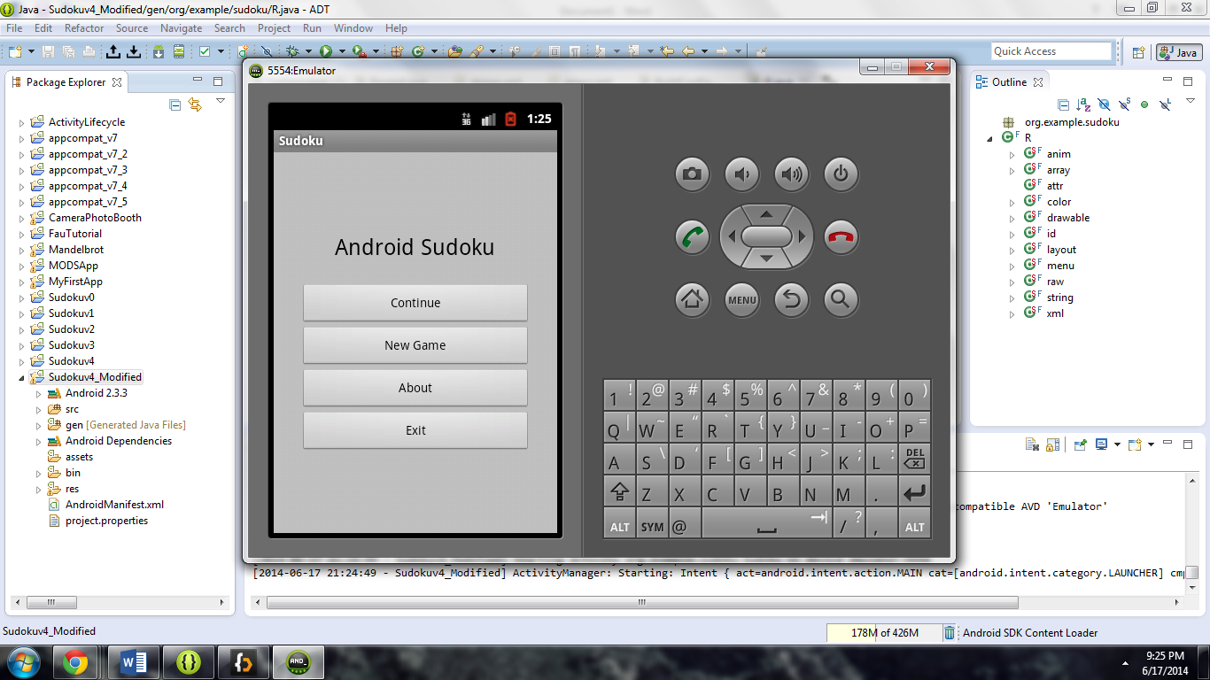

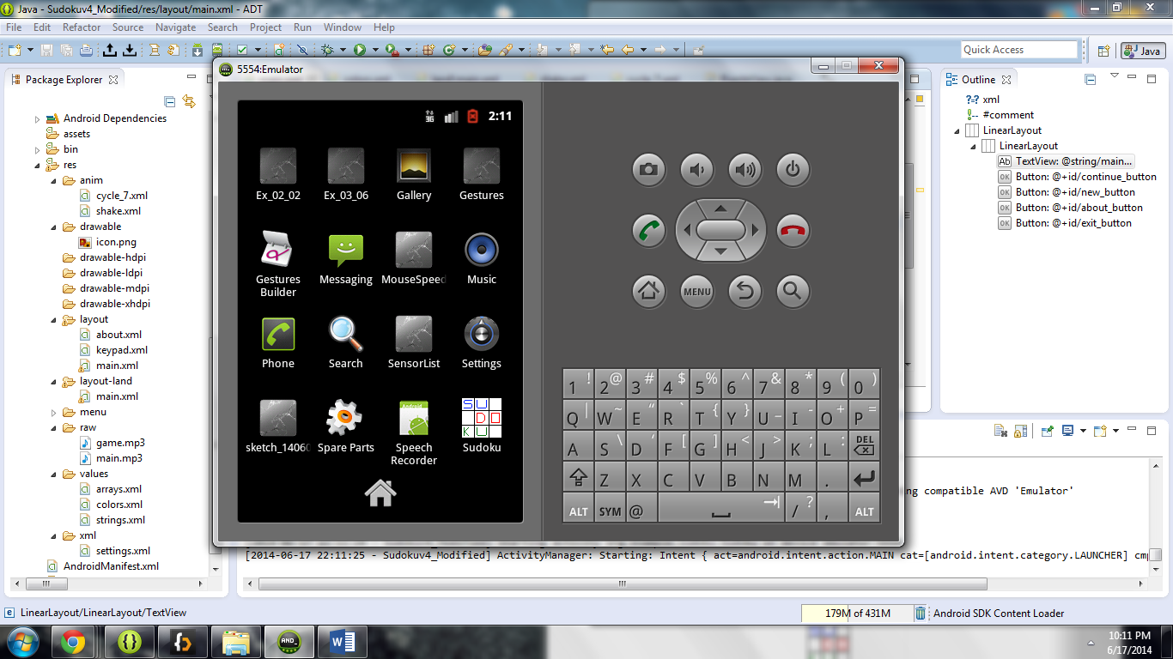

### About

The modifications made to version 4 of the Sudoku app include the following:

* New icon
* New background fill on the main menu
* Different color text on the main menu
* New music

To modify the color of the background I had to make the following change to the values/colors.xml:

<resources>

<color name=*"background"*>#C0C0C0</color>

<color name=*"puzzle_background"*>#ffe6f0ff</color>

<color name=*"puzzle_hilite"*>#ffffffff</color>

<color name=*"puzzle_light"*>#64c6d4ef</color>

<color name=*"puzzle_dark"*>#6456648f</color>

<color name=*"puzzle_foreground"*>#ff000000</color>

<color name=*"puzzle_hint_0"*>#64ff0000</color>

<color name=*"puzzle_hint_1"*>#6400ff80</color>

<color name=*"puzzle_hint_2"*>#2000ff80</color>

<color name=*"puzzle_selected"*>#64ff8000</color>

</resources>

Changing the color of the main menu’s text color required another modification to the values/colors.xml, as well as a modification to the layout/main.xml and layout-land/main.xml:

<resources>

<color name=*"background"*>#C0C0C0</color>

<color name=*"main_title"*>#000000</color>

<color name=*"puzzle_background"*>#ffe6f0ff</color>

<color name=*"puzzle_hilite"*>#ffffffff</color>

<color name=*"puzzle_light"*>#64c6d4ef</color>

<color name=*"puzzle_dark"*>#6456648f</color>

<color name=*"puzzle_foreground"*>#ff000000</color>

<color name=*"puzzle_hint_0"*>#64ff0000</color>

<color name=*"puzzle_hint_1"*>#6400ff80</color>

<color name=*"puzzle_hint_2"*>#2000ff80</color>

<color name=*"puzzle_selected"*>#64ff8000</color>

</resources>

<LinearLayout

xmlns:android=*"http://schemas.android.com/apk/res/android"*

android:background=*"@color/background"*

android:layout_height=*"fill_parent"*

android:layout_width=*"fill_parent"*

android:padding=*"15dip"*

android:orientation=*"horizontal"*>

<LinearLayout

android:orientation=*"vertical"*

android:layout_height=*"wrap_content"*

android:layout_width=*"fill_parent"*

android:layout_gravity=*"center"*

android:paddingLeft=*"20dip"*

android:paddingRight=*"20dip"*>

<TextView

android:text=*"@string/main_title"*

android:textColor=*"@color/main_title"*

android:layout_height=*"wrap_content"*

android:layout_width=*"wrap_content"*

android:layout_gravity=*"center"*

android:layout_marginBottom=*"20dip"*

android:textSize=*"24.5sp"* />

<TableLayout

android:layout_height=*"wrap_content"*

android:layout_width=*"wrap_content"*

android:layout_gravity=*"center"*

android:stretchColumns=*"*"*>

<TableRow>

<Button

android:id=*"@+id/continue_button"*

android:text=*"@string/continue_label"* />

<Button

android:id=*"@+id/new_button"*

android:text=*"@string/new_game_label"* />

</TableRow>

<TableRow>

<Button

android:id=*"@+id/about_button"*

android:text=*"@string/about_label"* />

<Button

android:id=*"@+id/exit_button"*

android:text=*"@string/exit_label"* />

</TableRow>

</TableLayout>

</LinearLayout>

</LinearLayout>

<LinearLayout

xmlns:android=*"http://schemas.android.com/apk/res/android"*

android:background=*"@color/background"*

android:layout_height=*"fill_parent"*

android:layout_width=*"fill_parent"*

android:padding=*"30dip"*

android:orientation=*"horizontal"*>

<LinearLayout

android:orientation=*"vertical"*

android:layout_height=*"wrap_content"*

android:layout_width=*"fill_parent"*

android:layout_gravity=*"center"*>

<TextView

android:text=*"@string/main_title"*

android:textColor=*"@color/main_title"*

android:layout_height=*"wrap_content"*

android:layout_width=*"wrap_content"*

android:layout_gravity=*"center"*

android:layout_marginBottom=*"25dip"*

android:textSize=*"24.5sp"* />

<Button

android:id=*"@+id/continue_button"*

android:layout_width=*"fill_parent"*

android:layout_height=*"wrap_content"*

android:text=*"@string/continue_label"* />

<Button

android:id=*"@+id/new_button"*

android:layout_width=*"fill_parent"*

android:layout_height=*"wrap_content"*

android:text=*"@string/new_game_label"* />

<Button

android:id=*"@+id/about_button"*

android:layout_width=*"fill_parent"*

android:layout_height=*"wrap_content"*

android:text=*"@string/about_label"* />

<Button

android:id=*"@+id/exit_button"*

android:layout_width=*"fill_parent"*

android:layout_height=*"wrap_content"*

android:text=*"@string/exit_label"* />

</LinearLayout>

</LinearLayout>

The music and application icon were changed by replacing the already existing files in the /res directory with new ones.